# CS 255 System Design Document

## UML Diagrams

### UML Use Case Diagram

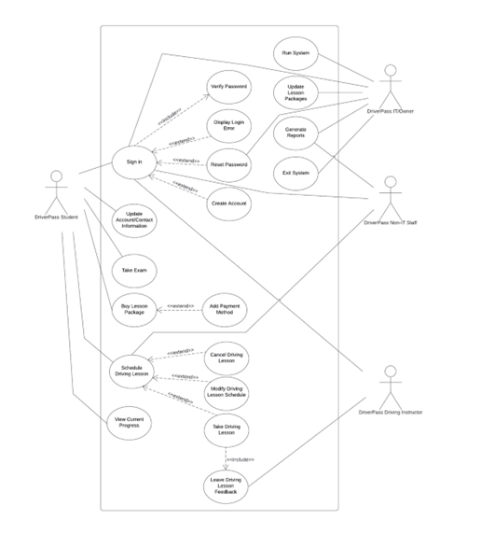

### UML Activity Diagrams

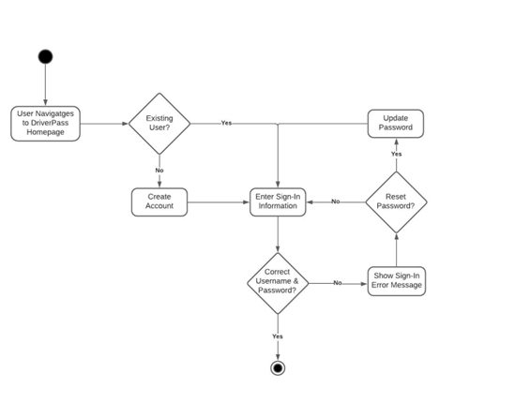

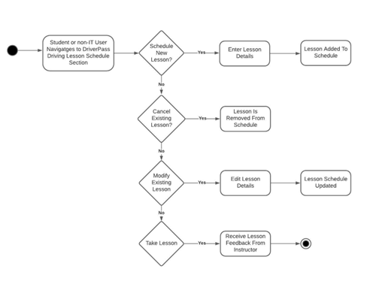

### UML Sequence Diagram

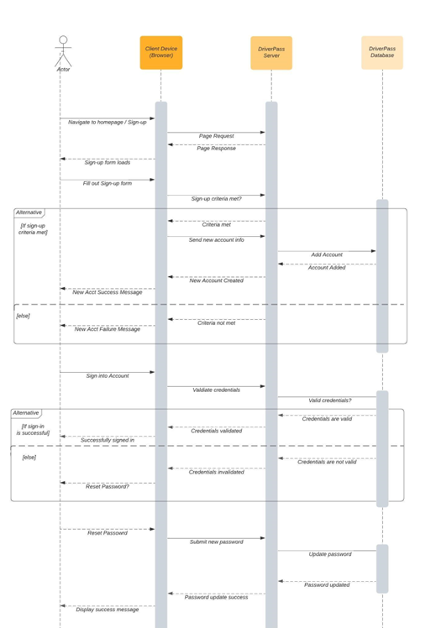

### UML Class Diagram

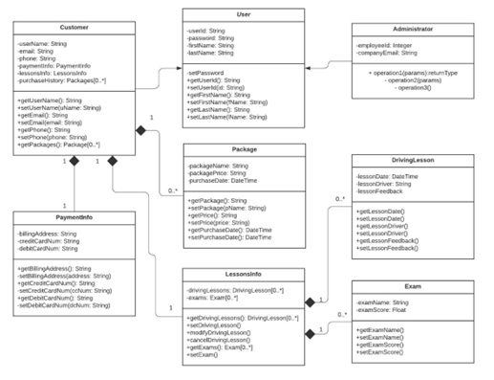

## Technical Requirements

Requirements:

Web-Based:

* Accessed through a modern web browser through either a mobile or desktop device
* Client server (Cloud Based) with modern hardware that hosts the application environment and stores data.
* Continuous sustainment updates

DMV Updates:

* Continuous checks with the official DMV rule set to ensure updates are properly implemented.
* Update classes and sustainment tests as DMV rule set changes
* Change driving lessons and what needs to be taught based on DMV rule changes

Security:

* Different authorities with varied access and accountability (Admin, User, Instructor, Etc.)
* Notifications provided upon security breaches or policy breaches
* OAuth registration
* 2FA optional
* SSL and TLS will be required

RESTFUL API:

* Allows runtime changes to ensure changes and hotfixes will be easily implemented.
* Make changes to the database remotely

User Interface:

* Home Page
* Account registration
* Course material access
* Ability to reserve lessons
* Account information page (Student, Teacher, Admin, Etc.)
* Communication page (Teacher to Student/Student to Teacher/Student to Admin etc.)

Maintenance (Other):

* Updates will be run at lowest average online users on a scheduled basis with reasonable notification beforehand.
* Routine preventative maintenance will occur to sustain dependency versions and ensure latest security protocols are maintained.
* Latest TLS and SSL protocols will be maintained.
* LDAP transactions must be encrypted, and latest cryptographic protocols should be maintained.